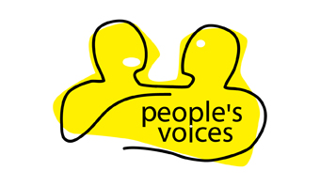
Referral Form

Name of person wanting an advocate
Address

Postcode
Telephone/mobile number |  | OK to leave voice mail Yes □ No □  OK to Text Yes □ No □
Does this person know that an advocate is being requested? |  | YES  NO
Reason for wanting an advocate (please include as much detail as possible, using another sheet if necessary).
If there are any issues about lone working please list them on a separate sheet and attach.
Disability: (please tick)  □ Learning difficulty  □ Mental health user  □ Physical disability  □ Sensory impairment | Age: (please tick)  □ 16-19  □ 20-29  □ 30-64  □ 65+ |  | Ethnic Background:  ………………………..
Has the person wanting an advocate used Peoples Voices before? |  | □ YES: write in name of previous advocate:  ………………………………………………..  □ NO
Name and organisation of person completing this form (please print)
Job title and contact numbers
Email address
Date

 |  |  |  | Office Use Only
Please return to: | Clare O’Driscoll  People's Voices  1 King George V Road  Amersham Bucks HP6 5TT |  | Tel: 01494 732 792  Fax: 01494 722 463 | Date received  Date visited
Company No 3135100 Registered Charity No 1051952 Registered address 1 King George V Road, Amersham, Bucks, HP6 5TT
People's Voices is a registered in England and Wales as a company and limited by guarantee

